# CS 255 System Design Document Template

This template lays out all the different sections that you need to complete for Project Two. Each section has guidance to prompt your thinking. You will need to continually reference the interview transcript as you work to make sure that you are addressing your client’s needs. There is no required length for the final document. Instead the goal is to complete each section based on what your client’s needs are. Remove this note when you are finished, and replace all bracketed text with the relevant information.

## UML Diagrams

### UML Use Case Diagram

*Next page ->*

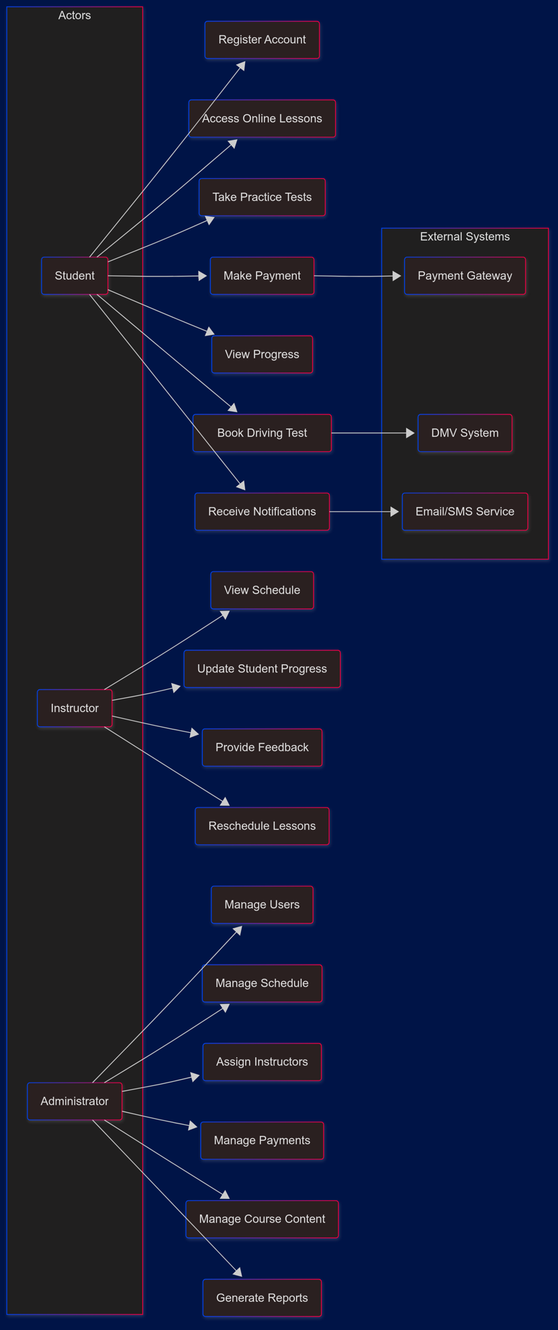

### UML Activity Diagrams

***Activity Diagram for Take Practice Tests***

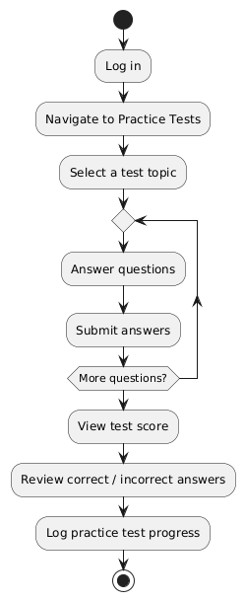

***Activity Diagram for Scheduling Driving Test***

*next page ->*

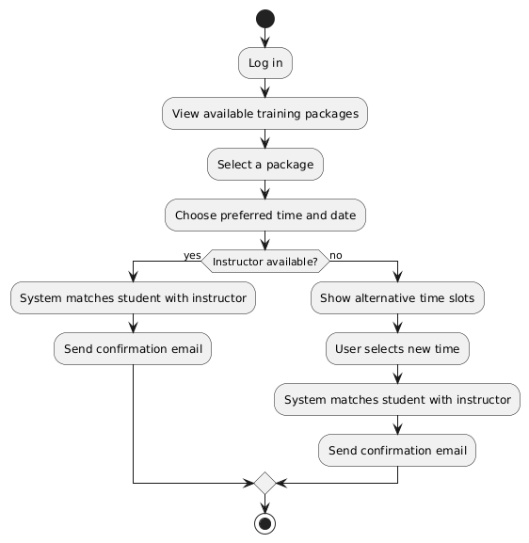

### UML Sequence Diagram

***Sequence Diagram for Scheduling Driving Test***

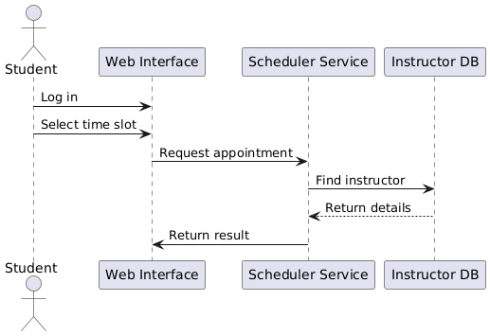

### UML Class Diagram

***Class Diagram for DriverPass System***

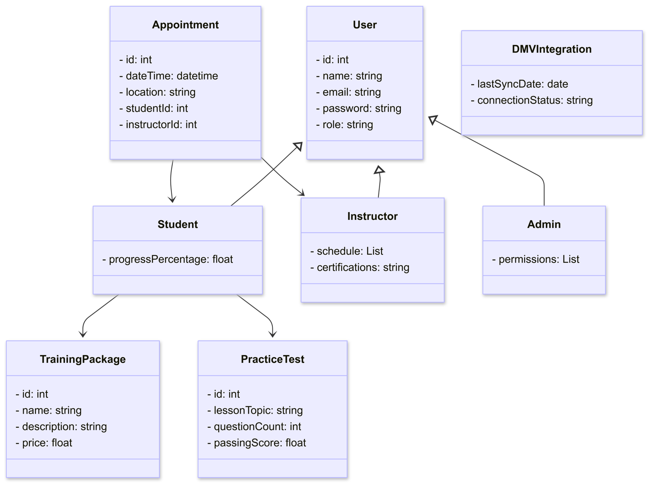

## Technical Requirements

To support the functional and non-functional requirements described above, the DriverPass system will have the following technical requirements.

* The system will be fully web-based and accessible via a web browser
* The systems backend will be hosted in the cloud to ensure easy scalability and accessibility.
* Access to a secure and scalable database to store user information, appointments, lessons and course progression.
* Role based access to easily manage employee / student access
* All communication will be through HTTPS
* Sensitive data like user credentials and student information will be securely encrypted
* Login attempts will be tracked and accounts will be locked after multiple failed attempts
* The system will have a secure connection to a third party payment processor
* Integration with the DMV API to access updated rules as well as scheduling driving tests for students
* The system will have an interface for system admins to manage users, lessons, and other support needs
* The system will have a web interface that allows for the offline downloading of lessons
* The system will be modular and scalable to allow for easy maintenance and updates without much system downtime